Roles in Tech, Portfolio Collaboration, & JS Review

Roles in Tech
Programming skills are useful in a wide variety of jobs, not just software engineering jobs. Though we think Techtonica best prepares you for a job as a software engineer, your unique background may lend itself to find work in another field within the tech industry. We will have a Career week a little later in the program but for now, it’s important that you learn that there are more opportunities in the industry than being a “software engineer”. Some of those are:
- Web & mobile development jobs
- Engineering specialties jobs
- Security & testing jobs
- Data & Analytics jobs
- Developer support jobs
- Management jobs

✨New Concepts for Today!✨
Always, always check that you are linking to the correct files! From this day forward we will be checking for this in your projects and it will be noted as a part of your evaluations. Linking to the appropriate area is imperative when working cross functionally across teams and team-members as well as implementing your code.

Deploying
If you’re working on a personal project, where to deploy that project is a personal decision. But, when you’re working in an office, you don’t have that opportunity. So, let’s take advantage of this time. Share with the group if you know of any deploying platform that you recommend for personal projects.
- Why do you like their system?
- Is it free?
- How did you learn about it?

Feel free to ask your mentors what platforms to deploy personal projects they use or recommend.

⚠️Note: You DO NOT need to deploy anything this week if you are feeling overwhelmed, we are just starting the conversation

⭐⭐⭐⭐⭐Show Off Your Portfolio - During the Project Review!⭐⭐⭐⭐⭐

Remember, these are goals:
- 50+ commits
- At least 1 PR
- CSS
  - At least 3 style properties applied to text
  - Border
  - Use of columns
  - Use of at least 1 ID
  - Use of at least 3 web design patterns
  - Override a CSS rule in your code in an obvious way at least once
  - Change display property of at least 1 element
  - Have at least 1 style change for narrow, medium, and wide browser views
- HTML
  - Headers
  - Sections
  - Semantic Tags
  - Links to your social media accounts
  - A contact form asking for a name (required), email (required), phone number (not required), and address (not required). (By not required, I mean the fields need to be present on the form, but they do not need to be filled out in order to submit the form)
  - Add contact information for yourself
  - Photo

Portfolio: Code Collaboration and Review
An important part of learning to be a good software developer is learning how to read code that you didn’t write. The best way to learn this is by reading the code of your cohort-mates, and commenting. Remember that open source is about collaboration and sharing information and knowledge

For this section you should pair-program with a partner the whole time. Complete this section with one partner's project, then switch reviews to another partner’s project. Spend about 40 minutes on each person's project. Each person should spend 20 minutes "driving" and 20 minutes "navigating" for each of the projects.
- Is there a README.md that is informative and has clear set up instructions? If not, submit a PR for that! Work on this together.
  - Fork your partner's project and use git to download it to your computer.
  - Create a new branch and make changes on that throughout this section.
- For each change you make on your project or your partner's (a bug fix, a feature add, etc), practice making a PR for your changes, on a new branch, rather than pushing it straight to main.
- Leave a 'review' of the PRs created for your site. To practice the code review process, find at least one small change to request, such as changing punctuation, improving a comment, or whatever else you think of - this is feedback iteration!
- Your partner should make the change and push another commit to the branch that implements your change request
- Now you can approve the PR, then merge it!

Get ready to take a good break this weekend! I want to hear one thing that everyone is looking forward to this weekend at wrap up 😃

End of Milestone Themes

Skills you should have from this milestone:
- Understand what conflict is
- Common ways to address conflict
- Become better at solving conflicts

Soft / Core Skills
- Tell me about yourself!
- What did you learn about yourself in the implicit bias test?
  - What else can you use the same “story” for?
  - What are some of your weaknesses?
  - How do you challenge yourself to grow?
  - What have you done to create a safe work environment for your coworkers?
  - How do you work in a diverse environment?
  - What is the most challenging aspect for you of working in a diverse environment?

- What are your goals in your next job?

Git / Terminal / Shell
- Please define the terminal, bash, zsh, git. How are they similar, how are they different?

HTML
- What is form validation?
- How to create HTML forms.
- How to add validation in the attributes.
- How to submit the form.
- Define what type of input the following are:
  - Text
  - Radio
  - Checkbox
  - Select
- Understand how the <label> relates to the form element
  - (Note there are 2 ways of adding a label to a form field, what are they?)
- What is in the form “event” on submit

Javascript
- What is Global Scope?
- What is Local Scope?
- What is the difference between global and local scope?
- How does one access variables created inside a function outside of the function?
- What is Closure?
- What is a switch statement, when would I use one?
- Why a switch statement over an if/else?
- What is the syntax of a switch statement?
- What is the “break” part of a switch statement, and what will happen if no break statement is used?
- What is a JS Map?
- When should I use a Map?
- What is a JS Set?
- When should I use a Set?

JS Date Time Object
- What is the Date Object?
- How do I make a new Date instance?
- What day corresponds to 0 in Date()?
- What month corresponds to 0 in Date()?
- What are the advantages of using numerical dates (milliseconds) vs. using object dates (new Date())?
- How do you add and subtract dates? (Date math)

Test-Driven Development
- What test cases do you need?
- What are edge cases?
- When does one create the tests in TDD?

Object Literal
- What is the syntax for declaring an Object?
- What are Complex Objects? Give an example.
personOne =
{ name: ‘string’
pet: {
petName: ‘string’,
petAge: number,
isAdopted: bool
adoptionInfo {
Date: date,
Location: ‘string’
adoptionName: ‘string’
}
}
Birthday: dateObject
}
personOne.pet.isAdopted
personOne.pet.adoptionInfo.location
Let inputRequested = {user input}
personOne.pet.adoptionInfo[inputRequested]
personOne[‘pet’][‘adoptionInfo’][‘location’]
- Explain some built-in Object Methods in JavaScript. (.keys, .hasOwnProperty, for… in loops)
- What is a property of an Object?
- What is the difference between dot and bracket notation?
- How do you access nested objects inside an array?
myArray = [{name: ‘me’, lastName: ‘jones’}, {name: ‘you’, lastName: ‘smith’}]
What is the first and last name of the last index?
myArray[1].name, myArray.1[‘lastName’]

CSS
- What are the different methods to add CSS into an HTML page?
- How do you use CSS to style forms?
- How do you use CSS to style a table?

Runtime Complexity
- What is runtime complexity?
- How do we talk about runtime complexity?
- Give me an example of each the following run times,
  - Constant, linear, O(n^2)
  - Take a look at the small text snippet, try to explain what the run time complexity is.
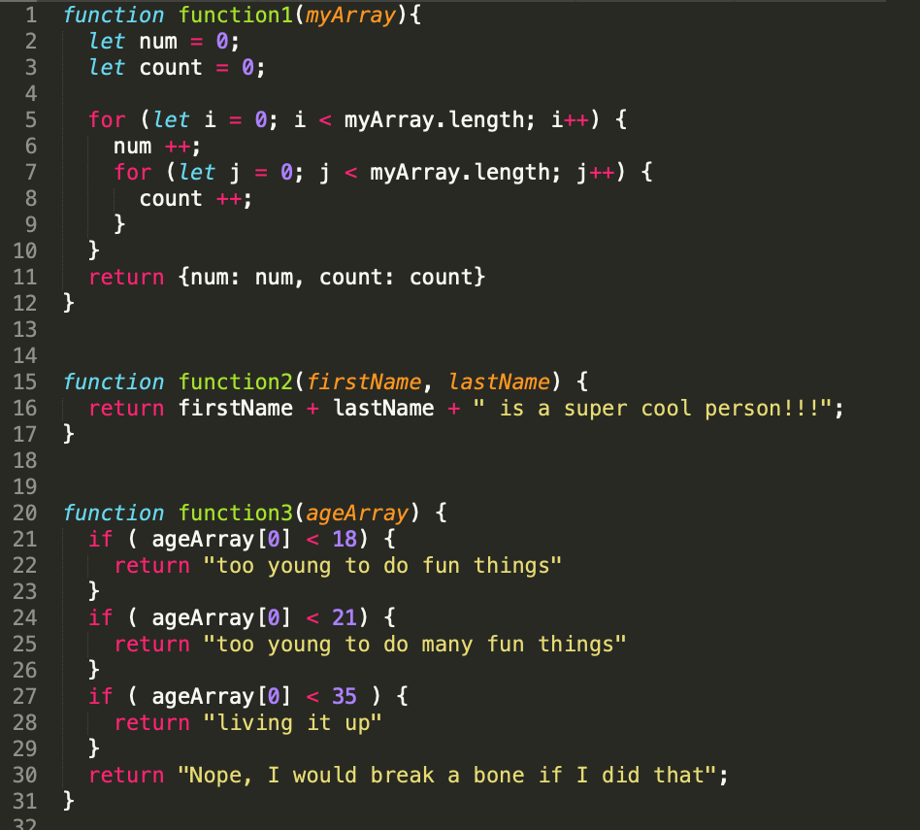

EOD Quiz: Technical Question 3 Practice

